**1. Login to your Azure account and on the Azure Dashboard search for “aks”**

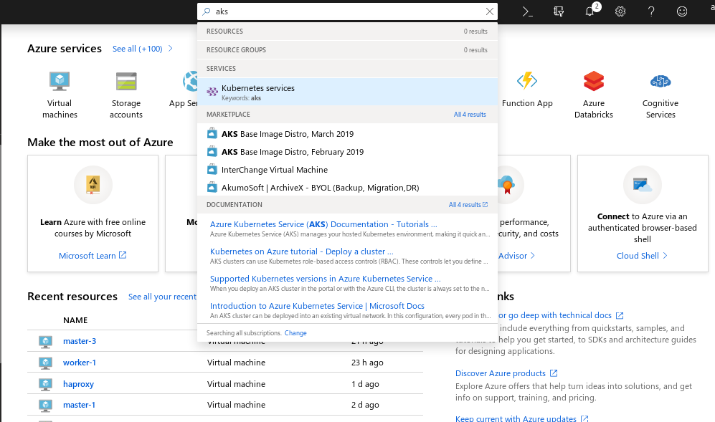

**2. Click on create Kubernetes Service** 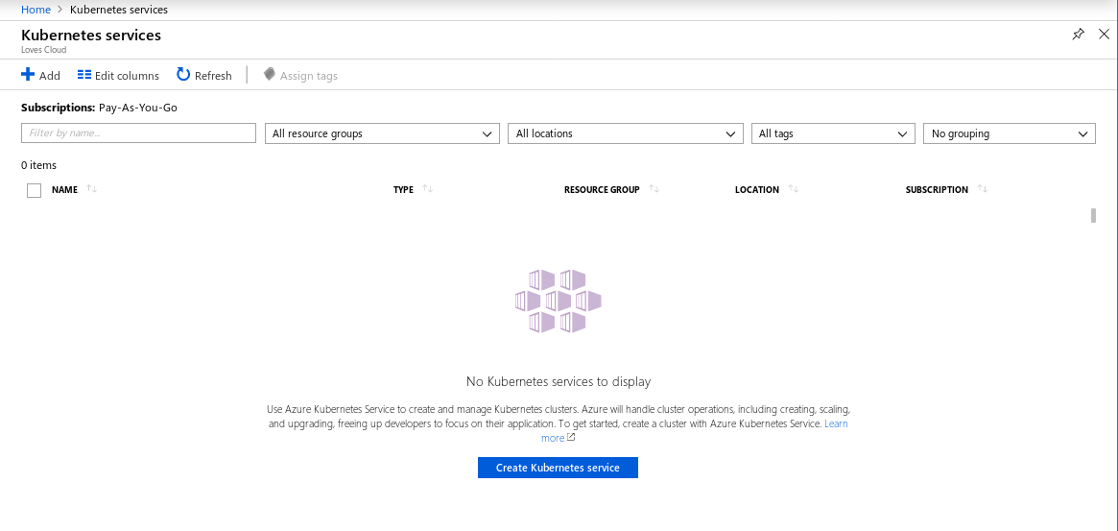

Enter **Kubernetes Cluster name:**

Keep following fields as default

**Region:**

**Kubernetes version:**

**DNS name Prefix:**

Scroll down, Under **SCALE** section,

Keep **Node Size** as default

Change **Node Count:** 2

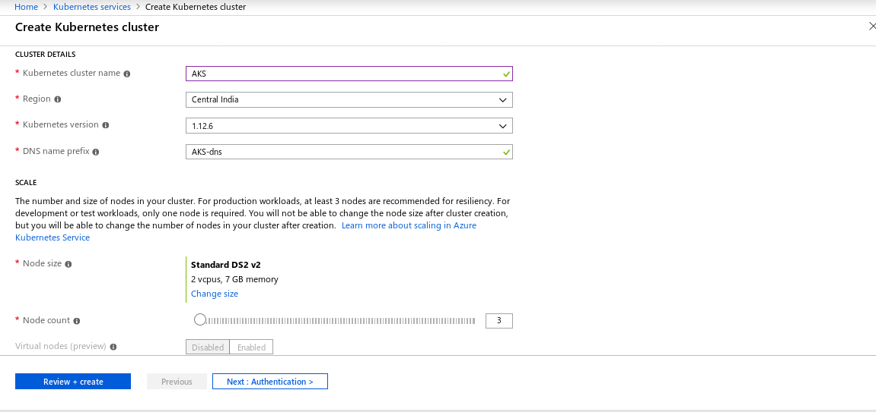

Click on **Next: Authentication**Under **Kubernetes authentication and authorization ,Enable RBAC** NO

Click on **Next : Networking >**

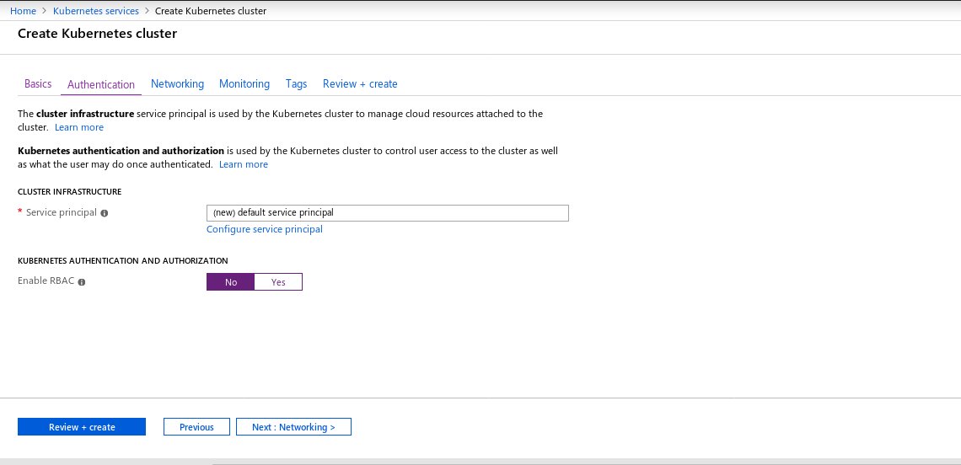

3. Click on **Next : Monitoring >**

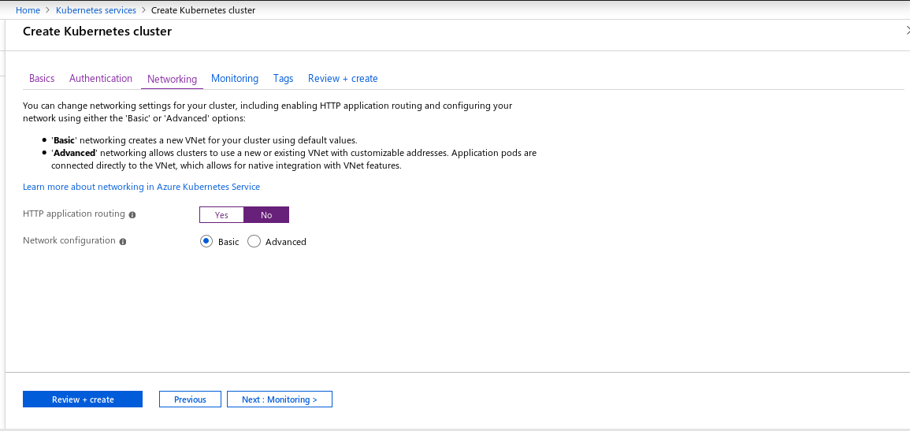

**4.** Keep **Enable Container monitoring :** Yes and Click on **Next : Tags >**

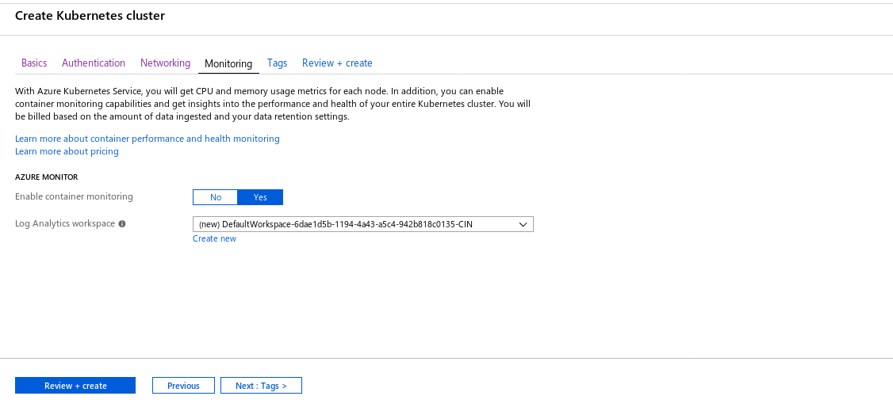

**5.** Add **Tags** if requiredand click on **Review+Create**

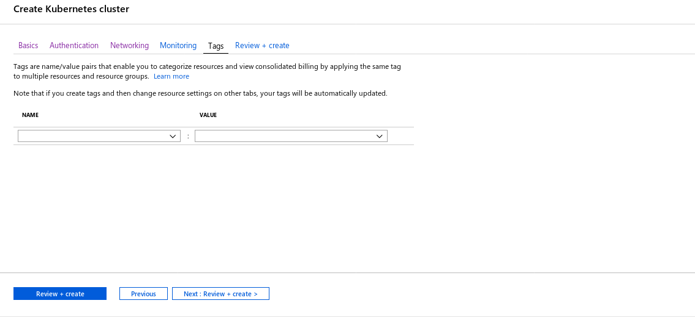

**6.** Once it shows **Validation passed**, Click on **Create**

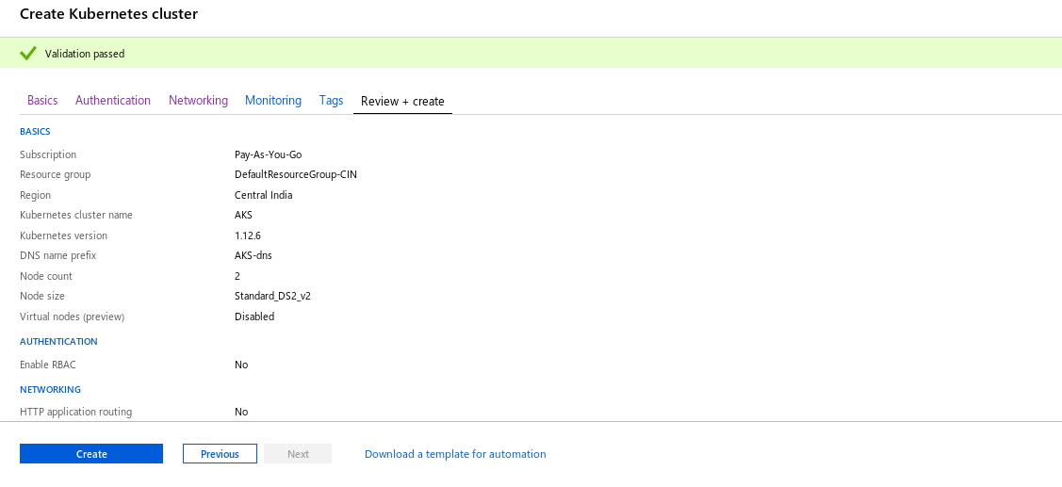

7. Once Deployment is complete, Click on**Go to resource**

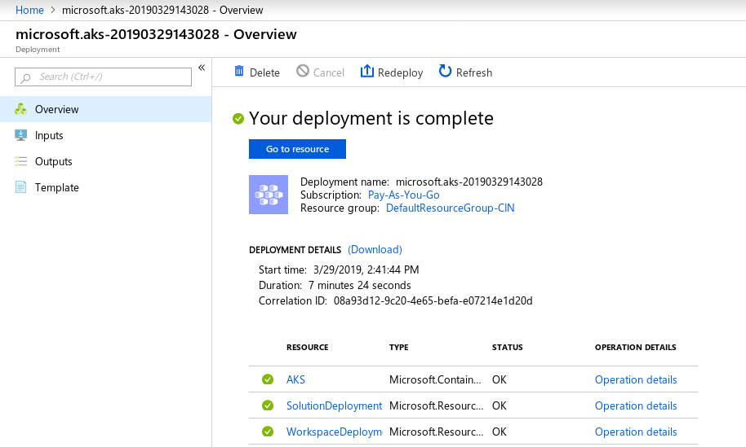

**8. Click on View Kubernetes dashboard**

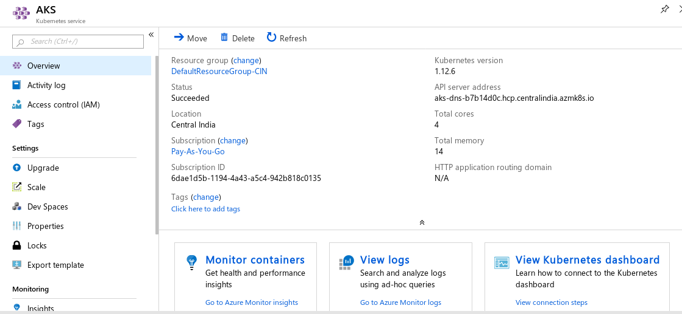

**9.** View **Kubernetes dashboard**

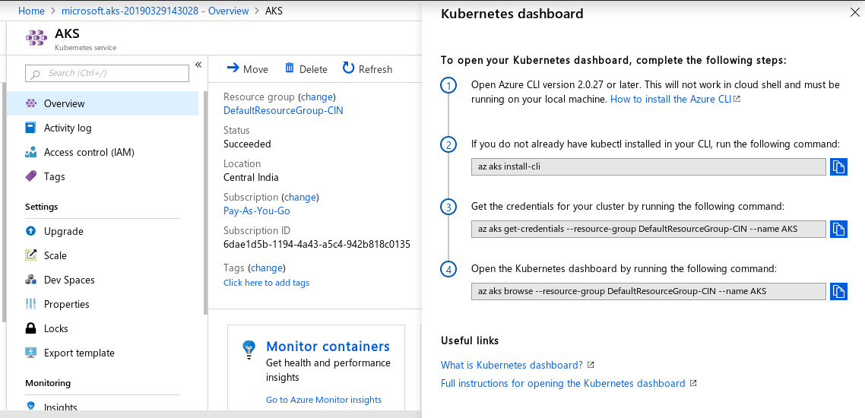

**10. Open a command prompt on the Windows laptop and terminal on mac laptops.**

**Installing az-cli on windows**

**11. Goto the below url**

[**https://docs.microsoft.com/en-us/cli/azure/install-azure-cli-windows?view=azure-cli-latest**](https://docs.microsoft.com/en-us/cli/azure/install-azure-cli-windows?view=azure-cli-latest)

**12. Download the MSI Installer and run it.**

1. Open your CMD
2. Run the login command.
3. Azure CLI.

13. On your command prompt run the below command.

|  |
| --- |
| az login |

1. If the CLI can open your default browser, it will do so and load a sign-in page.
2. Otherwise, you need to open a browser page and follow the instructions on the command line to enter an authorization code after navigating to<https://aka.ms/devicelogin> in your browser.
3. Sign in with your account credentials in the browser.

**14. After login in to your azure account, run the commands as mentioned in the Kubernetes Dashboard instructions as shown in the screenshot step-8.**

**15. Run the first command to install kubectl**

|  |
| --- |
| **az aks install-cli** |

**Note : Once you run the first command you need to export the kubectl path as shown in the instructions from your output of**

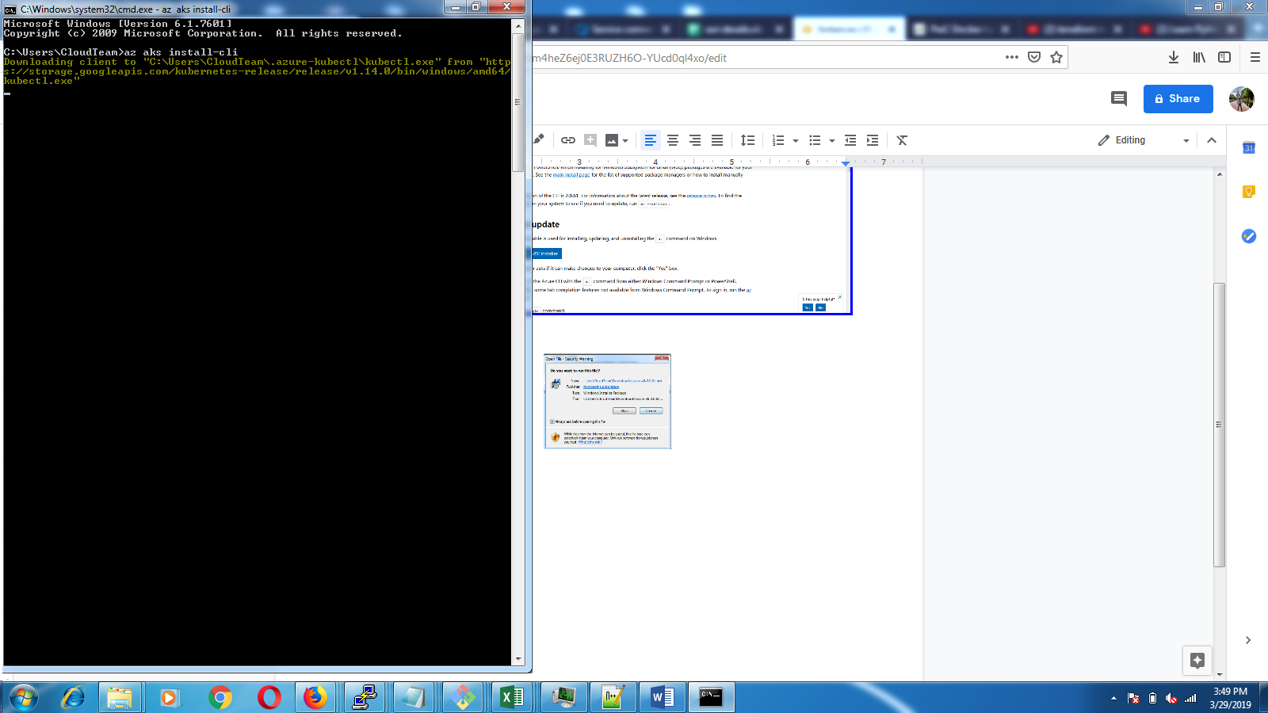

**Example**

**16. Update <user-name> in the below command as shown in the output from the above command.**

|  |
| --- |
| **> set PATH=%PATH%;C:\Users\<user-name>\.azure-kubectl** |

**17. Get the credentials for your cluster by running the following command: Update the --name AKS to the name of your cluster that you set during cluster initialization.**

|  |
| --- |
| **az aks get-credentials --resource-group DefaultResourceGroup-CIN --name AKS** |

**18. Run the below command to check if you are able to connect to the az aks from your local command prompt/terminal**

|  |
| --- |
| **kubectl get nodes** |

**19. Open the Kubernetes dashboard by running the following command: Update --name AKS with your Clustername**

|  |
| --- |
| **az aks browse --resource-group DefaultResourceGroup-CIN --name AKS** |

**Installing az-cli on MAC**

**20. If you do not have brew open the terminal and run the below command to install brew**

|  |
| --- |
| **/usr/bin/ruby -e "$(curl -fsSL https://raw.githubusercontent.com/Homebrew/install/master/install)"** |

**21. Now, install the azure-cli by running the below command**

|  |
| --- |
| **brew install azure-cli** |

**22. Once the az-cli is installed run the below command to login to your azure account**

|  |
| --- |
| **az login** |

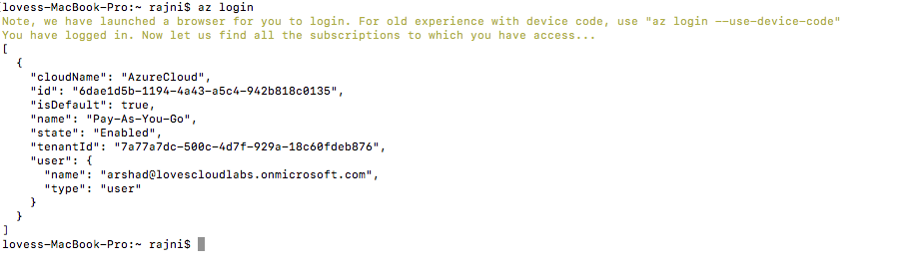

**23. After you login run the below command to install az aks cli**

|  |
| --- |
| **az aks install-cli** |

**24. Run the commands from step 17,18 & 19 from the mac terminal to get the kube config on your local terminal and open the dashboard.**

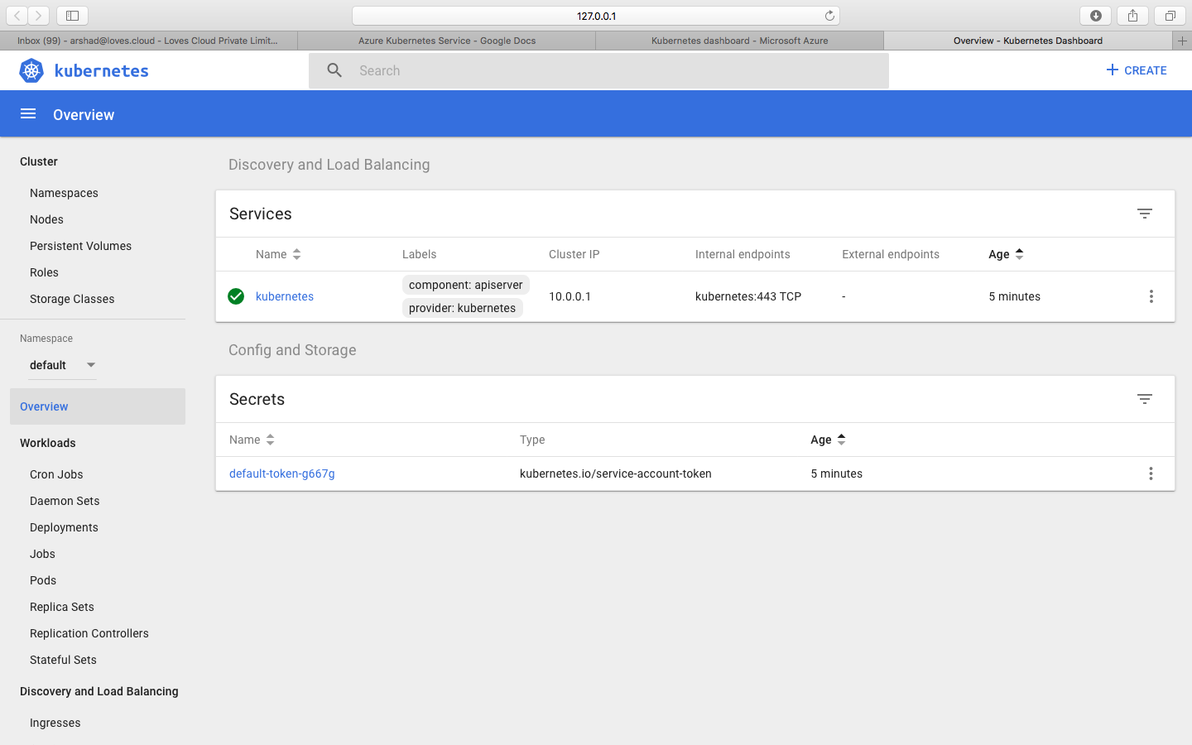

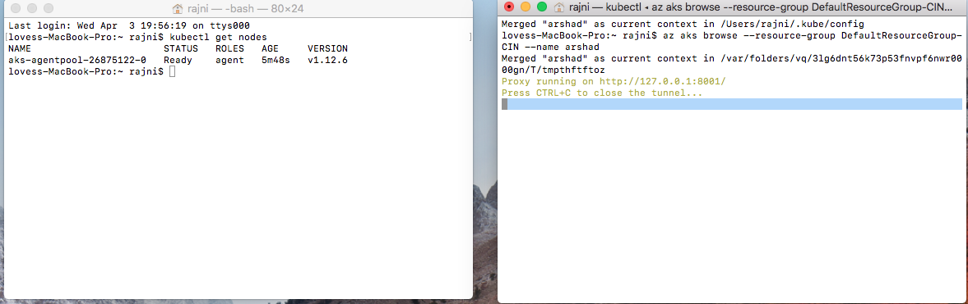

**25. Run a Deployment from the Dashboard.**

On the Kubernete Dashboard, Click on Create on the TOP right and paste the below script in create deployment from yaml.

|  |
| --- |
| apiVersion: apps/v1 kind: Deployment metadata:  name: dotnetapp spec:  selector:  matchLabels:  run: dotnetapp  replicas: 2  template:  metadata:  labels:  run: dotnetapp  spec:  containers:  - name: dotnetapp  image: lovescloud/docker.net.demo:latest  ports:  - name: port80  containerPort: 80 --- apiVersion: v1 kind: Service metadata:  name: dotnetapp  labels:  run: dotnetapp spec:  type: NodePort  ports:  - name: port80  port: 80  protocol: TCP  selector:  run: dotnetapp |

**Click on the create button.**

**26. Go to Deployments to see the PODS getting deployed.**

**Open the CMD/terminal on your local windows/mac. And the below command to check the deployment from the CLI.**

**On windows launch a new CMD again and run the below command update the <user-name>**

**> set PATH=%PATH%;C:\Users\<user-name>\.azure-kubectl**

**27. Run the below command to check the deployment and service details.**

|  |
| --- |
| **kubectl get deploy** |

|  |
| --- |
| **kubectl get svc** |